**EXPERIMENT NO. 02**

TO CREATE THE UNIVERSITY DATABASE FROM THE ER MODEL USING DATA DEFINITION LANGUAGE (DDL) IN SQL.

DESCRIPTION:-

*DDL STANDS FOR “DATA DEFINITION LANGUAGE”. A DDL IS A LANGAUGE USED TO DEFINE DATA STRUCTURES AND MODIFY .FOR EXAMPLE:-DDL COMMANDS CAN BE USED TO ADD,REMOVE,OR MODIFY TABLES WITHIN A DATABASE.*

DDL COMMANDS:-

1. THE CREATE TABLE COMMAND:- IT DEFINES EACH COLUMN OF THE TABLE UNIQELY.EACH COLUMN HAS MINIMUM OF THREE ATTRIBUTES,A NAME,DATA TYPE AND SIZE.

SYNTAX:-

CREATE TABLE &lt;table name&gt; (&lt;col1&gt;&lt;datatype&gt;(&lt;size&gt;),&lt;col2&gt;&lt;datatype&gt;&lt;size&gt;));

[SQL_1] SQL&gt; CREATE TABLE department(department_name VARCHAR2(50) PRIMARY

KEY,

location VARCHAR2(50) );

OUTPUT:-

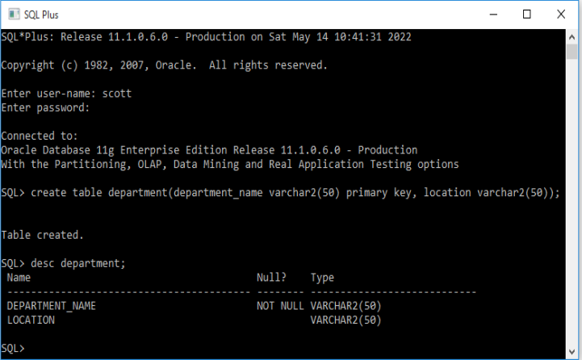

02. THE ALTER TABLE COMMAND:-

THIS COMMAND IS USED TO ADD, DELETE OR MODIFY COLUMNS IN

AN EXISTING TABLE. YOU SHOULD ALSO USE THE ALTER TABLE COMMAND TO ADD AND DROP VARIOUS CONSTRAINTS ON AN EXISTING TABLE.

SYNTAX:-

ALTER TABLE&lt;tablename&gt; ADD (&lt;new col&gt;&lt;datatype(size),&lt;new col&gt;datatype(size));

[SQL_3] SQL&gt; ALTER TABLE department ADD(dept_id NUMBER(2));

OUTPUT:-

b) Modifying existing columns.

Syntax:

ALTER TABLE&lt;tablename&gt; MODIFY (&lt;col&gt;&lt;newdatatype&gt;(&lt;newsize&gt;));

[SQL_4] SQL&gt; ALTER TABLE department MODIFY (dept_id NUMBER(3));

OUTPUT:-

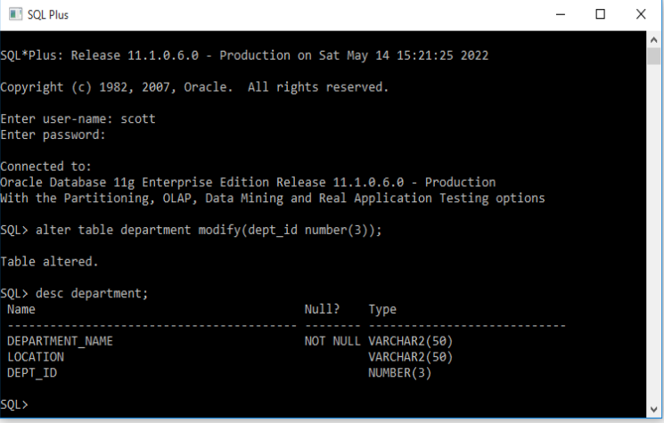

3. The TRUNCATE Command:- This command is used to remove all rows from the table, but

the structure of the table still exists.

Syntax:

TRUNCATE TABLE &lt;tablename&gt;

First insert records into the course table &amp; then use truncate command.

Syntax: INSERT INTO&lt;tablename&gt; values(col1,col2,col3……..coln);

[SQL_6] SQL&gt; INSERT INTO course values(114,’cloud computing’,’1 year’, ’CSE’);

Insert 3 records into the table course using the above query &amp; then truncate the table.

[SQL_7] SQL&gt; TRUNCATE TABLE course;

OUTPUT:-

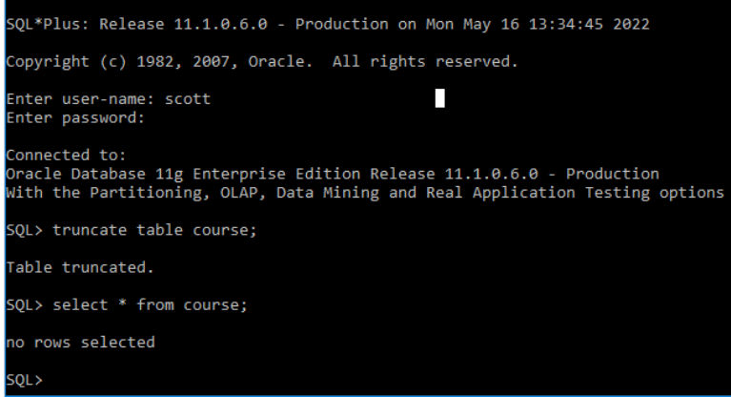

04:- The RENAME Command:- This rename command is used to change the name of an existing database object(liketable, Column) to a new name. Renaming a table does not make it to lose any data is containedwithin it.

Syntax: RENAME &lt;oldtable&gt; to &lt;new table&gt;

[SQL_8] SQL&gt; RENAME course to course1;

OUTPUT:-

